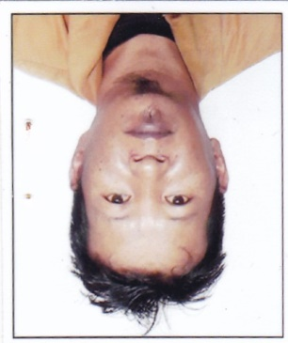

ADMIT

Ms/Mr **R. Lalrammawia** Roll No. **53** to the Departmental Examination for **Section Assistant (SA)** under Public Works Department.

**His/her attention is drawn to the instructions overleaf.**

Name of the Centre : **CONFERENCE HALL, C.E (Highway) OFFICE, PWD.**

Name of Venue : **TUIKHUAHTLANG, AIZAWL.**

|  |  |  |
| --- | --- | --- |
| Date | Time | |
| 27.11.2014 | Morning  9:30 AM- 12:30PM | Evening  1:00 PM - 4:00 PM |
| **Engineering Paper** | **Accounts Paper** |

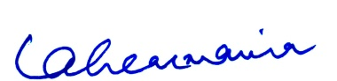

(LALREMMAWIA)

Deputy Director(Admn)

Engineer-in-Chief’s Office, PWD,

Mizoram:Aizawl

INSTRUCTION TO CANDIDATES

1. *Candidates will be admitted to the examination Hall /Room on production of this Admit Card and original ID such as EPIC or Aadhaar with a view to establish the true identity of the candidate.*
2. *Admission will ordinarily be refused to a candidate who is late by 10 Minutes from the start of the examination.*
3. *Loss of Admit Card must be reported to the Head of Department immediately and duplicate copy of the same will be issued on payment of Rs.50/-(Rupees Fifty) only.*
4. *No candidate shall be permitted to leave the Examination Hall/Room before half hour after the examination is started.*
5. *The candidates should not bring any articles such as books, notes, loose sheets, mobile phones, pagers, digital diaries, calculators, etc. Inside the Examination Hall/Room.*
6. *Deleted.*
7. *Answers must be written/marked using Blue or Black Ball pen and pencils should not be used unless drawing maps, diagrams, etc is required.*
8. *Particulars/Details to be filled up in the answer paper should be filled up completely and correctly, answer scripts of candidates failing to do so will not be evaluated.*
9. *Candidates must attempt questions in accordance with the directions on each question paper. If questions are attempted in excess of the prescribed number, only the question attempted first up to the prescribed number shall be evaluated and the remaining ignored.*
10. *Answer scripts of candidates who do not complete the examination will not be evaluated.*
11. *Wrongly numbered on un –numbered answer will not be evaluated.*
12. *Any candidate who applies for his/her Marks should enclose original or attested copy of Admit Card.*
13. *Candidates detected in using unfair means or commutating with one another or found in possession of unauthorized books, papers, mobile phones, pagers, digital diaries, calculators, etc during the examination shall be expelled and their names struck off the rolls. They will be liable to be debarred from applying or all future examinations and selection to be conducted by the Department.*
14. *No candidate shall leave the Examination Hall/Room without prior permission of the Invigilator.*