GOVERNMENT OF MIZORAM
OFFICE OF THE SUPERINTENDING ENGINEER, PWD.,
CENTRAL CIRCLE : AIZAWL, MIZORAM

No. T-11014/NIT/2024/SE-CC/PWD/3 : Dated Aizawl, the 9th September, 2024

NIT NO.1/SE-CC/PWD/2024-2025 Dt.09.09.2024

The Superintending Engineer, Central Circle, PWD, Aizawl on behalf of the Governor of Mizoram invites sealed item rate tender from approved and eligible contractors of Mizoram PWD and firms for the work given below:-
Sl.  No | Name of work | Estimated cost put to tender in Rs. P | Earnest Money Deposit (EMD) in Rs. P |  | Time for Completion | Cost of tender document in Rs. P | Eligible Contractor
Sl.  No | Name of work | Estimated cost put to tender in Rs. P | Tribal  1% | Non-Tribal  2% | Time for Completion | Cost of tender document in Rs. P | Eligible Contractor
1 | 2 | 3 | 4 | 5 | 6 | 7 | 8
1. | Patch repair and full seal coating of MZU Roads at essential places. | 2,01,23,000.00 | 2,01,230.00 | 4,02,460.00 | 6 months | 1500.00 | Class-IV and above

- Tender document will be issued to eligible registered PWD Contractors provided that they produce definite proof from the appropriate authority.

- Tender document may be obtained from the office of the Superintending Engineer, Central Circle, PWD, Aizawl from 10.09.2024 to 03.10.2024 up to 12:00 noon.

- Earnest Money should be deposited along with the tender documents in separate envelop marked as “Earnest Money” in the form of Treasury Challan/Deposit at call receipt/Fixed Deposit/Demand Draft of RBI recognized Bank issued in favour of the Superintending Engineer, Central Circle, PWD, Aizawl.

- Pre-bid meeting will be held on 26.09.2024 at 1:00 pm in the office of the Superintending Engineer, Central Circle, PWD, Aizawl.

- Bids shall be opened on 03.10.2024 at 1:00 pm.

- Both sealed envelopes (EMD and tender document) marked as “Earnest Money” and “Tender” shall be submitted together in another sealed envelope superscripted with the name of work. The envelope marked “Tender” shall be opened whose Earnest Money, place in the other envelope marked as “Earnest Money” is found in order.

- For any clarification with respect to the binding process, the prospective bidder may contact the office of the Superintending Engineer, Central Circle, PWD, Aizawl.

- The amount put to tender is inclusive of GST and any Taxes /Cess.

Other details can be seen in the bidding documents.

Sd/-
( LALCHHUANA )
Superintending Engineer, PWD,
Central Circle, Aizawl.

Memo No. T-11014/NIT/2024/SE-CC/PWD/3 : Dated Aizawl, the 9th September, 2024

Copy to:-

1. P.S to the Hon’ble Minister, PWD. Etc., Mizoram, Aizawl for favour of kind information.
2. The Commissioner & Secretary to the Govt. of Mizoram, PWD., for favour of kind information.
3. The Engineer-in-Chief, PWD., Mizoram for favour of kind information.
4. The Chief Engineer, PWD, Highways/Roads/Building & Other Deptt, for favour of kind information.
5. The Director, I&PR for favour of kind information and necessary action. He is requested to publish the simplified notice (enclosed 3 copies) in two local newspapers for two issues only.
6. All Superintending Engineer, PWD for favour of kind information with spare copy for display in the Notice Board.
7. The Executive Engineer, PWD, Aizawl Road North Division for information and necessary action.
8. The Executive Engineer, PWD, Aizawl Road South Division/Hmuifang Division for information.
9. The Executive Engineer (IT), PWD, Office of the Engineer-in-Chief, PWD for information and necessary action. He is requested to upload the Notice Inviting Tender in the PWD website.
10. The President, Class-I, II, III & IV Contractor for information.
11. Notice Board.
12. Guard file.

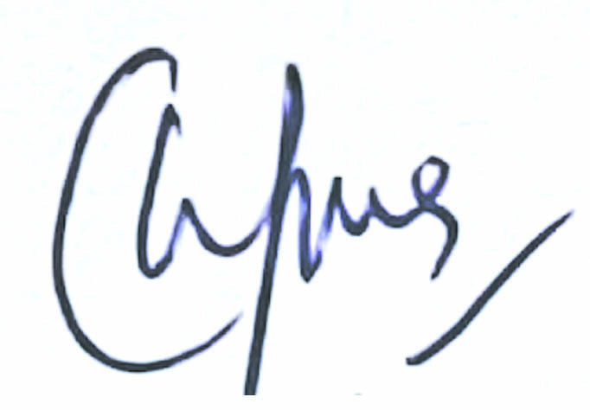
Superintending Engineer, PWD,
Central Circle, Aizawl.

